FIRST GRADING PERIOD STUDY QUESTIONS

      - What is the supreme law of the land?
- The government
- The constitution
- The Supreme Court
- The legislature

2. Which of the following below summarizes the roles of the United States Constitution?
- Interprets the meaning of laws, appeals laws, vetoes old laws
- Defines the government, provides executive leadership, creates the laws
- Protects basic rights of Americans, defines the government, sets up the government
- Makes the laws, vetoes bills, sets up the government

3. What is the name of the first ten amendments of the United States Constitution?
- The Preamble to the Constitution
- The Declaration of Independence
- The Articles of Confederation
- The Bill of Rights

4. How long is the governor of Florida’s term in office?
- Two years
- Four Years
- Six Years
- Eight Years

5. Identify the qualifications a candidate must have to become a governor in the state of
Florida.
- 30 years old; United States citizen for 5 years; Florida resident for 2 years
- 35 years old; United States citizen for 10 years; Florida resident for 4 years
- 40 years old; United States citizen for 15 years; Florida resident for 6 years
- 45 years old; United States citizen for 20 years; Florida resident for 8 years

6. Which body of the Florida legislature has the most elected members?
- House of Representatives
- Senate
- General Assembly
- Supreme Court

7. Charters give cities a license to be a city. Once a city receives a charter from a state, what
is the term called that relates to the status of that city?
- Authorized
- Incorporated
- Unincorporated
- Chartered

8. What is another name used for city courts?
- Municipal Courts
- Appellate Courts
- Superior Courts
- Supreme Courts

Analyze the following statements to answer question 9.
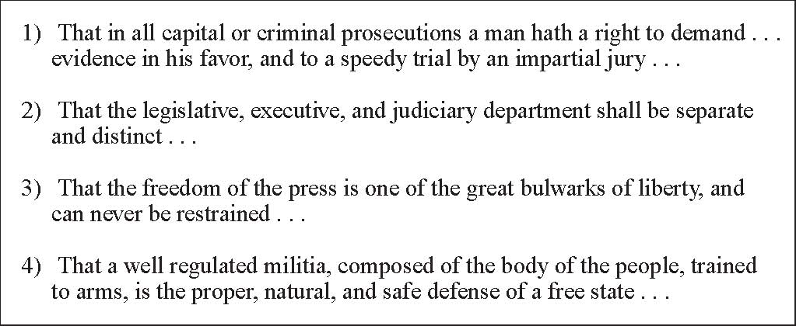
Source: Public Domain / U.S. National Archives and Records Administration

9. The statements above are from the 1776 Virginia Declaration of Rights. Which statement reflects the Enlightenment ideas of government as expressed by Montesquieu?
- 1
- 2
- 3
- 4

10. To whom does the United States Constitution give the authority to declare war?
- the President
- the Congress
- the Supreme Court
- the Military

11. The process of selecting justices for the Supreme Court supports which principal of
government?
- levels of government
- checks and balances
- branches of government
- check on judiciary power

12. Which process is an interpretation of a civic duty required by U.S. law for 18-year-old male citizens?
- registering with Selective Service
- volunteering for a political campaign
- serving as a legislative page
- voting in all elections

- Which of the following groups has the primary responsibility to inform citizens of national government regulations?
- executive departments and agencies
- senators and representatives
- special interest groups
- the federal courts

- Which statement below supports the Anti-Federalists in the struggle over ratification of the United States Constitution?
- The Constitution should limit state government.
- The Constitution should protect fundamental rights.
- The Constitution should create a strong, national government.
- The Constitution should prevent the election of amateur politicians.

- Which statement describes a similarity between the state and the federal governments under the United States Constitution?
- Both levels of government allow for the election of judges.
- Both levels of government have the power to ratify treaties.
- Both levels of government allow for the collection of taxes.
- Both levels of government have the power to appoint ambassadors.

- Which action relates to a civic responsibility of United States citizens?
- voting during local elections
- paying taxes
- attending school
- maintaining security

Analyze the following ideas by John Locke to answer question 17.

Ideas of John Locke
Rulers receive the right to govern the people.
Unjust rulers can be forced from power.

- Based on the quotation above, which form of government would John Locke
most oppose?
- Republic
- Dictatorship
- Representative Democracy
- Constitutional Monarchy

Analyze the following chart to answer question 18.
Natural rights
Separation of powers
Political equity

- The teachings of Enlightenment thinking listed above provided the basis for which of the following?
- Limited power of the monarch
- Religious freedom
- Acceptance of the Theory of the Divine
- Voting rights granted to commoners

- What were both the Magna Carta and the English Bill of Rights designed to do?
- Limit the power of the monarch
- Provide for religious freedom
- Legitimize the Theory of Divine Right
- Provide commoners the right to vote

- Which answer summarizes the qualifications a person must meet to be a member of the United States House of Representatives?
- Be at least 21 years of age, have been a U.S. Citizen for at least 7 years, be a legal resident of the state in which he or she lives
- Be at least 25 years of age, have been a U.S. Citizen for 10 years, be a legal resident of the state he or she represents
- Be at least 25 years of age, have been a U.S. Citizen for 8 years, be a legal resident of the state he or she represents
- Be at least 25 years of age, have been a U.S. Citizen for at least 7 years, be a legal resident of the state in which he or she lives

- Which answer choice correctly compares the ages and the length of term of service between the members of the United States House of Representatives and the United States Senate?
- Senators must be at least 25 years of age and can serve 6 years; the representatives must be at least 30 years of age and can serve at least 2 years
- Senators must be at least 30 years of age and can serve 2 years; the representatives must be at least 25 years of age and can serve 6 years
- Senators must be at least 30 years of age and can serve 6 years; the representatives can be at least 25 years of age and serve 2 years
- Senators must be at least 25 years of age and can serve 6 years; representatives can be 25 years of age and can serve 2 years

- According to Article 1, Section 8, of the United States Constitution, what is the name of the powers granted to Congress?
- delegated powers
- special powers
- implied powers
- power to impeach

- According to the rule in the U.S. House of Representatives, which is the correct order of steps formulated in the impeachment process?
- Charges by House; tried in Senate; majority vote required; two-thirds vote to convict
- Charges by the House; majority vote required; tried in Senate; two-thirds vote to convict
- Tried in Senate; charges by the House; two-thirds vote to convict; majority vote requires
- Charges by the house; two-thirds vote to convict; majority vote required; tried in Senate

- Explain what happens after a bill is introduced in the house?
- The President signs the bill.
- The President keeps bill for 10 days without signing.
- The bill goes to a committee for study and hearings.
- Conference committee tries to reach a compromise.

- How are the requirements for qualifying to be a governor defined?
- In the individual state’s constitution
- The United States Constitution
- The citizens of the United States
- Congress

- How does small claims court compare to other courts?
- The parties speak in front of a jury.
- No private attorneys allowed; parties are only allowed public defenders.
- The parties may appeal their cases.
- No attorneys needed; parties in the dispute speak directly to the judge.

- How are local governments established in the United States?
- The citizens help to formulate the local government.
- Local governments are established by the federal government.
- They are established by and receive powers from the state governments.
- The legislature establishes local governments for each state.

- Which answer summarizes the main purposes of county governments?
- Supervise elections; enforce state laws; provide such things as roads, schools, libraries
- Help state government collect taxes; supervise elections; enforce state laws
- Help state government collect taxes; supervise elections; enforce laws; provide such things as roads, schools, libraries, health and welfare services, law enforcement
- Enforce state laws, help state collect taxes, oversees all county issues

- What was the name given to the supporters of the Constitution who were in favor of a strong national government?
- Anti-federalists
- Communists
- Federalists
- Activists

- In which two years did most of the states ratify the Constitution?
- 1777 and 1778
- 1887 and 1888
- 1878 and 1879
- 1787 and 1788

- Which of the following was the purpose of the United States Constitution?
- To create a state government
- To plan an executive branch of government
- To bring in new justices and judges
- To create a national government

- Which branch of government interprets the law?
- Legislative
- Senate
- Judicial
- Executive

- If one state’s population is larger than another, how does that affect the number of senators they have?
- Both states have the same number
- Both states have a different number
- It depends on the states location
- Some states do not qualify to have senators

- Which of the following refers to the rule that state governments cannot make laws that conflict with those of the U.S. Constitution?
- Checks and Balances
- Federalism
- Bill of Rights
- Supremacy Clause

- Which of the following examples is NOT included in the Bill of Rights?
- Freedom of speech
- Employment
- Voting
- Freedom of religion

- If the President vetoes a bill, what steps can senators and representatives take to guarantee passage of the bill?
- Write letters to the Commander in Chief asking that he reconsider the matter and change his mind.
- Explain the matter to the justices on the Supreme Court and ask that they declare it unconstitutional.
- Speak with the President’s cabinet and ask for guidance according to the Supremacy Clause.
- Congress has the right to pass the bill if two-thirds of each house approves it.

- Which answer below explains why the Founding Fathers created a balance of power within our government?
- So that the Executive Branch would always be the most powerful
- So the power would be distributed equally among branches
- So the laws would never be unconstitutional
- So the Legislative Branch would always be in control

Analyze the following excerpt to answer questions 38.
“No Person except a natural born citizen, or a citizen of the United States at the time of the Adoption of this Constitution, should be eligible to the Office of the President; neither shall any person be eligible to that Office who shall not have attained to the Age of thirty-five Years, and been fourteen years a resident within the United States.” -Article II, United States Constitution

- Based on the qualifications above, which of the following people could NOT be a presidential candidate?

- Your 37 year old sister who was born in northern Florida and dreams of one day becoming the first female President.
- Your uncle who is a college professor, 43 years of age and born in Philadelphia.
- Your teacher who was born in Alaska 36 years ago and now lives in south Florida
- Your 50 year old neighbor, who was born in the U.S., lived in Cuba since the age of two and returned to the U.S. at the age of 48.

Analyze the following excerpt to answer question 39.
‘Every Bill which shall have passed the House of Representatives and the Senate, shall, before it becomes a Law, be presented to the President of the United States; if he approves he shall sign it, but if not he shall return it, with his Objections…” Article I, Section 8 United States Constitution

- Which of the following best describes the purpose of the above passage?
- Powers delegated to Congress
- Power of impeachment
- President’s veto power
- Jurisdiction of federal courts

- Which term is given to a person who is not born a U.S. citizen, but has completed the legal process to gain citizenship?
- Naturalized citizen
- Citizen
- Immigrant
- Resident alien

Analyze the following diagram to answer question 41.

British Ignore Colonial Grievances

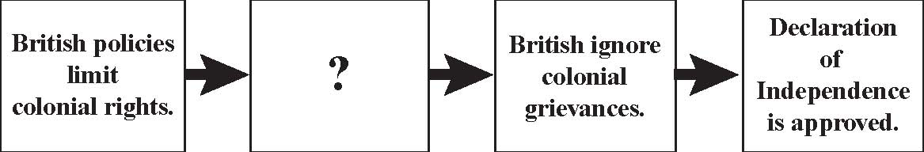

- Which action completes the above diagram?
- Colonial agricultural trade increases.
- Colonial religious devotion increases.
- Colonial demand for political change increases.
- Colonial demand for military assistance increases.

- A Japanese couple is visiting the U.S. While on vacation, the expectant mother has her baby; is the baby a U.S. citizen? Which answer is a valid statement of the scenario?
- No, because the mother is not a U.S. citizen
- Yes, because the child was born in the U.S.
- No, because the child’s parents were visiting the U.S.
- Yes, because the parents were previously U.S. citizens

- How did the U.S. Constitution solve a problem created by the Articles of Confederation?
- It avoided the issue of states’ rights.
- It allowed the states to elect representatives.
- It prevented the amendment of federal laws.
- It enabled the federal government to collect taxes.

- Which characteristic serves as a long-term protection against tyranny and is a foundation of liberty in the United States?
- the Commerce Clause
- the Elastic Clause
- the Right to Trial
- the Rule of Law

The diagram below shows some general eligibility requirements. Analyze the diagram to answer question 45.

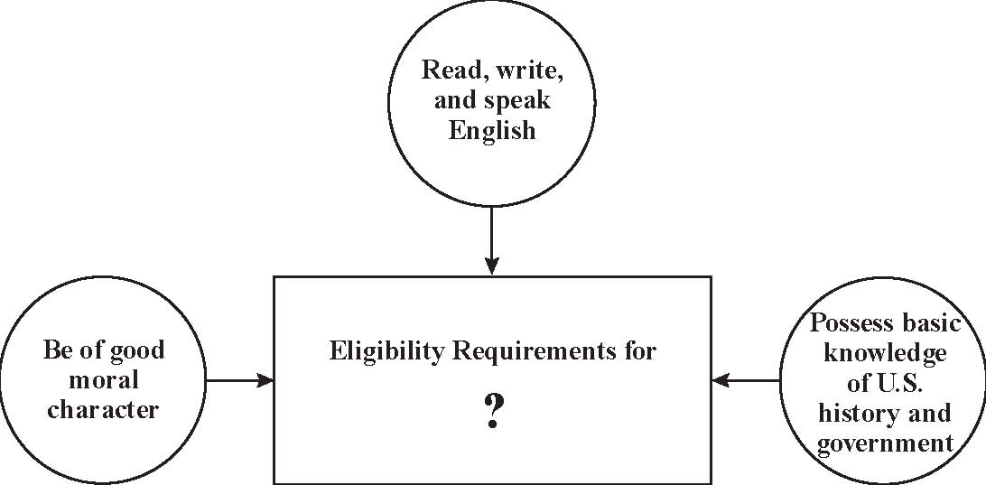

- Which statement completes the diagram?
- joining a Military Service
- obtaining a Driver’s License
- becoming a Naturalized Citizen
- receiving a Social Security Card

- Based on the government system in the United States, which individual activity is used to directly influence legislative decisions?
- watching political debates on television
- discussing political issues at work
- collecting opinions for a yearbook
- gathering signatures for a petition

Analyze the illustration below to answer question 47.

The illustration below shows a legal document.

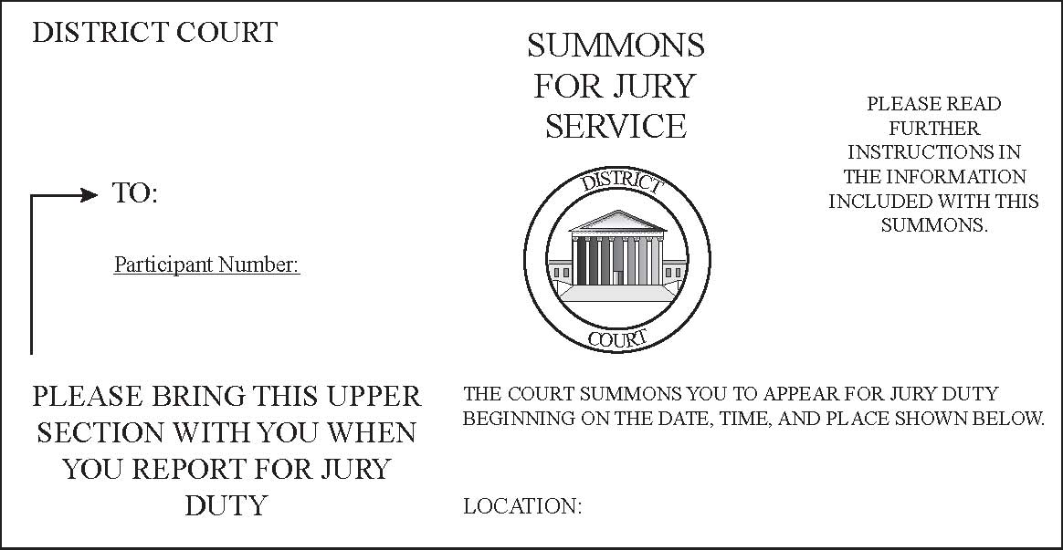

- Why are citizens obligated to respond to such documents?
- To guarantee court hearings remain public
- To guarantee courts provide probable cause
- To protect the constitutional right to be tried by one’s peers
- To protect the constitutional right to confront one’s accuser

- What do an absolute monarchy and an autocracy have in common?
- A single ruler
- A written constitution
- A national court system
- A single legislative house

- Which is the last step in amending the U.S. Constitution?
- The voters approve the amendment in a national election
- Three-fourths of the state legislatures ratify the amendment
- The president signs the amendment in a public ceremony
- Two-thirds of both houses of Congress ratify the amendmen

- Which philosopher’s political ideas lead to the American Revolution?
- John Locke
- Patrick Henry
- John Calvin
- Thomas Hobbes

- Which of the following famous political works greatly influenced late 18th Century political thinking?
- The American Tragedy
- Common Sense
- A Second Treatise on Government
- The Declaration of Independence

- Which document was most influenced by John Locke’s philosophy?
- The Bill of Rights
- The Preamble
- The Articles of Confederation
- The Declaration of Independence

- Which article of the U.S. Constitution gives the President the power to veto laws?
- Article I
- Article II
- Article III
- Article IV

- Which fundamental political idea is interpreted in the Declaration of Independence?
- The government should guarantee every citizen economic security.
- The central government and state government should have equal power.
- If the government denies its people certain basic rights, that government can be overthrown.
- Rulers derive their right from God and are therefore bound to govern in the nation’s best interest.

Analyze the following excerpt to answer question 55.
“The only representatives of the people of these colonies are persons chosen therein themselves; and that no taxes ever have been, or can be constitutionally imposed on them but by their respective legislatures.” -Statement by the Stamp Act Congress, 1765

- What is a valid conclusion that can be drawn from the above quotation?
- The colonial legislatures should be appointed by the English king with the consent of Parliament.
- Only the colonists’ elected representatives should have the power to levy taxes.
- The English King should have the right to tax the colonists.
- The colonists should be opposed to all taxation.

- In the Preamble to the U.S. Constitution, what is the meaning of the phrase, “We the People”?
- Government receives its power from the people and exists to serve them.
- The people express their will through political parties.
- The people express their will by directly creating laws.
- Government receives taxes from the people and exists to support them.

- Which explanation supports why the Mayflower Compact of 1620 was an important step in the development of democracy in America?
- It expressed the importance of self-government
- It established freedom of religion
- It created the first colonial judiciary
- It granted all males the right to vote

- Which document was formulated as an agreement signed in 1215 by King John and the English nobility establishing limited government and many of the same freedoms seen in the U.S. Bill of Rights?
- The Bill of Rights
- The Articles of Confederation
- The Mayflower Compact
- The Magna Carta

- Which statement best differentiates between an oligarchy and a monarchy?
- An oligarchy is ruled by one person and a monarchy is ruled by a few people.
- An oligarchy is ruled by a single political party and a monarchy is ruled by one person.
- An oligarchy is ruled by representatives of the voters and a monarchy is ruled on behalf a set of religious ideas.
- An oligarchy is ruled by a few people and a monarchy is ruled by only one person.

- What is the idea that gives each branch of government a way to make sure the other branches of government are not abusing their power?
- separation of powers
- unitary system
- checks and balances
- federal System

- Which term relates to the type of system where the government is elected by the people who are the majority of the population?
- democracy
- monarchy
- oligarchy
- autocracy

- How is a unitary system of government different from a federal system of government?
- A unitary system is led by representatives of people where each is chosen as a member but in a federal system power is shared between the central and state governments.
- In a unitary system the central government has all the power, but in a federal system power is shared between the central and state governments.
- A unitary system is made up of states that hold all of the key power and the central government is very limited but in a federal system power is shared between the central and state governments.
- In a unitary system the central government has all the power but a federal system is led by representatives of people where each is chosen as a member.

Analyze the following excerpt to answer question 63.
. . . Montesquieu was guided . . . in saying “There can be no liberty where the legislative and executive powers are united in the same person, or body” . . . he did not mean that these departments ought to have . . . no CONTROL over, the acts of each other. -James Madison, 1788
Source: Public Domain / Project Gutenberg

- Based on the passage above, which constitutional principle does Madison describe?
- separation of powers
- checks and balances
- popular sovereignty
- judicial review

- Which statement relates to the development of the 19th Amendment?
- freedom from unreasonable searches and seizures
- the right to keep and bear arms
- universal suffrage
- abolition of slavery

- What is the correct term given to a formal change made to the Constitution of the United States?
- amendment
- article
- bill
D. clause

